**Plots from clustering in R**

**K-Means Clustering:**

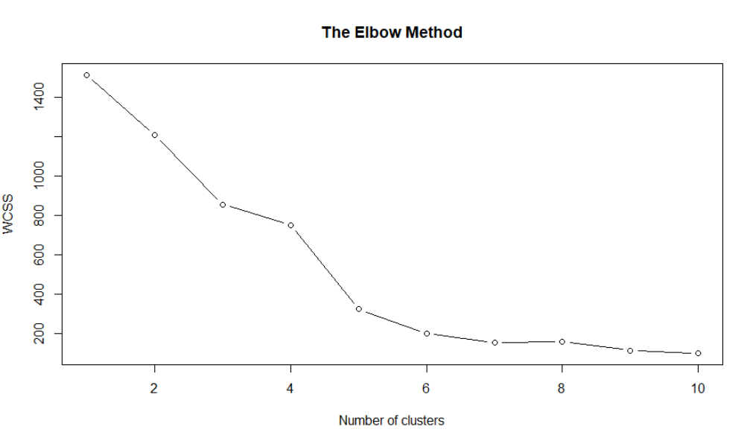  
Fig 1: Elbow method used to decide the number of clusters in K-Means

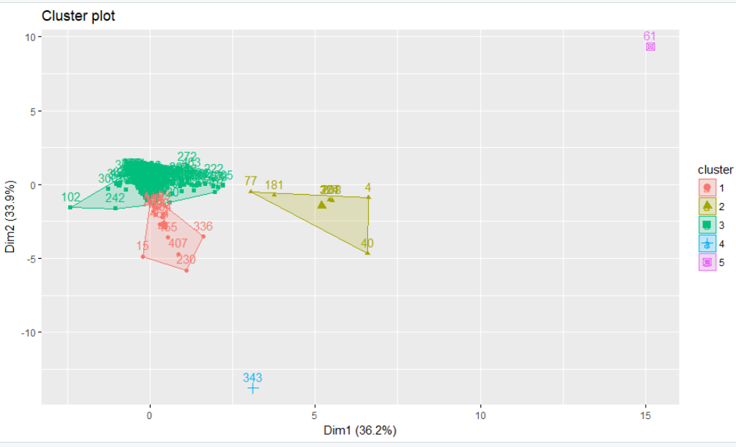

Fig 2: Cluster plot with K-Means clustering ; Found 5 clusters

**K-Medoid Clustering:**

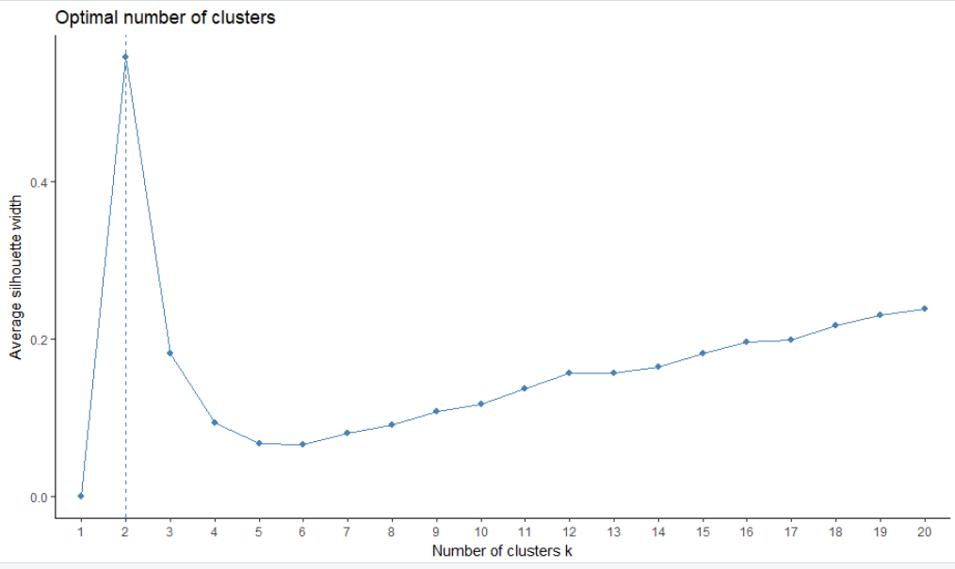

Fig 3: Silhouette method used to decide the number of clusters in K-Means

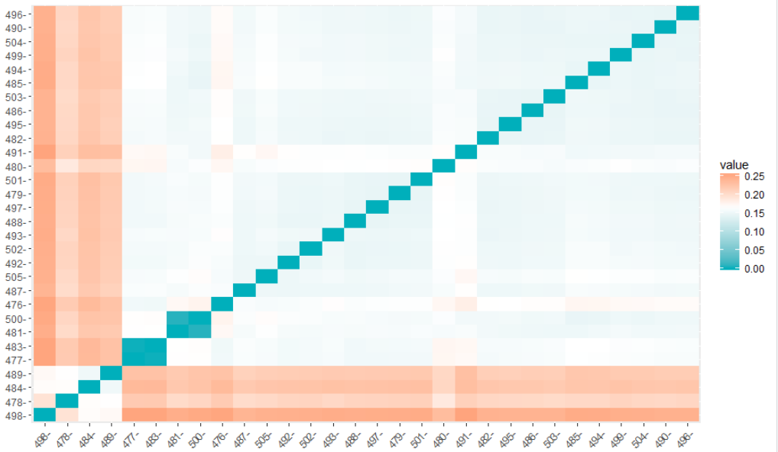

Fig 4: Dissimilarity Matrix of 500 companies using Gowers Distance